**MOBILE APP DEVELOPMENT**

**Table of Contents**

Description of the App 3

Social, Ethical, Legal and Security Issues Relevant to the App 3

Evidence of Professional Tool used to Support Development 4

Evidence of Agile Project Planning, Management, and Development Activities 8

Justify the Choice of Professional Tools and Agile Development Method 9

Reference List 11

# Description of the App

The current research work introduces designing, planning and building a mobile application for a tablet or smartphone device utilizing a specific agile development method. The researcher has produced a single Memo android app named Memoware utilizing Android SDK and Java programming language. Memoware is considered a memo app which is a decent way for keeping track of daily vital information. The users can basically use the current app for storing daily reminders, lists, or notes. Moreover, it is contemplated as a handy tool to keep thoughts organized and to keep key details. The researcher has expressed the main functionalities of the application as follows.

* The Memoware app is built for taking down a quick memo or note.
* The users can also add the title, tag, and main content of the memo in the application.
* The memos are automatically saved in the application; hence, the users don’t have to worry about losing any memos.
* The Memoware app also allows the user to edit the content of the saved memo as well.
* Furthermore, the users are also allowed by the Memoware app to search previously submitted memos by keywords.

Along with that, the Memoware app also consists of two main screens which effectively respond to the orientation and size of the device screen and all the data is efficiently transmitted from one screen to another screen. Together with that, local storage is also used by the Memoware app for storing all the information and data provided by the user to the app and by the app to the user.

# Social, Ethical, Legal and Security Issues Relevant to the App

**Social Issues**

The researcher has considered multiple social issues which are relevant to the app development including data security, possibilities for the app to be utilised for criminal or illegal activities and privacy concerns.

**Ethical Issues**

Moreover, there are various ethical issues relevant to the app which has been contemplated by the researcher which includes the way the personal data of the users are used in the app and the issues concerning the impact of the app on the user safety, accuracy of the information and many more (Berman and Carter, 2020).

**Legal Issues**

During the development of the application, the researcher followed all the relevant data protection regulations and laws. In addition, ***consumer protection law, copyright and trademark law*** and other relevant laws are also considered by the researcher (Müller *et al.* 2022).

**Security Issues**

In terms of security, the researcher has considered how the data will be protected and stored in the application. Furthermore, the researcher has also taken into account other security issues such as the possibility of the application being attacked or hacked, the possibility for the app to harm the users and many more.

# Evidence of Professional Tool used to Support Development

In the present section of the study, the researcher has provided pieces of evidence of the professional tool named Android Studio which has been utilized for supporting the development of the Memoware app.

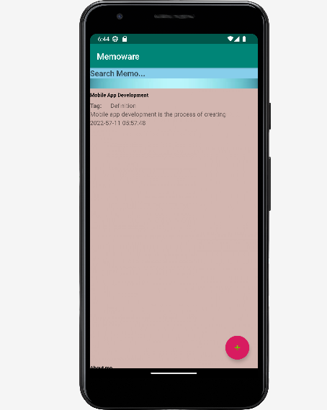

**Figure 1: Home Screen of Memoware App**

(Source: Developed in Android Studio)

In the above figure, the researcher has illuminated the home screen of the Memoware app which consists of a search bar at the top for searching memos (Hagos, 2019). After that, there is the list of previously submitted memos and at the bottom-right corner of the screen, there is a button that exists which leads to the add memo screen.

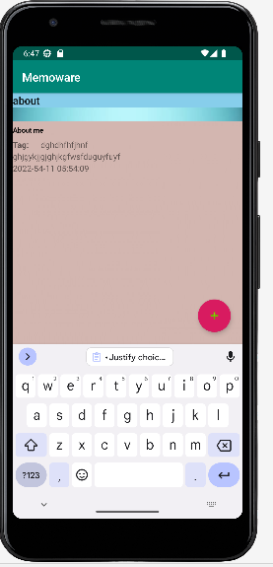

**Figure 2: Search Screen of Memoware App**

(Source: Developed in Android Studio)

After searching for a keyword on the home screen, the matched memo with the keyword will appear on the screen illustrated above. The search result also shows the title of the memo, the tag, content, created date and time of the memo.

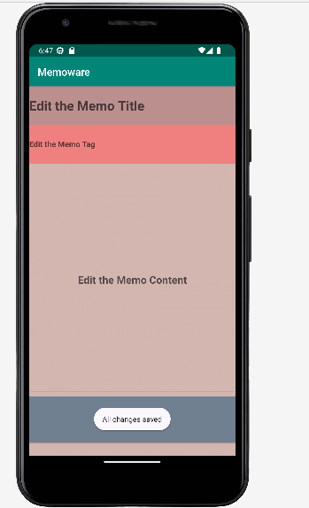

**Figure 3: Add Memo Screen of Memoware App**

(Source: Developed in Android Studio)

Clicking on the add button in the home screen leads to the add memo screen of the Memoware app depicted above. Here, the users have to provide the title of the memo, the tag and the content of the memo and then have to click on the Save the Memo button to store the memo (Megalingam *et al.* 2019).

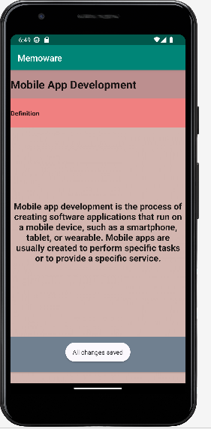

**Figure 4: Edit Memo Screen of Memoware App**

(Source: Developed in Android Studio)

The above screen appears after clicking on a particular memo present in the home screen of the Memoware app in which the user can edit the content, tag and title of the memo respectively.

# Evidence of Agile Project Planning, Management, and Development Activities

The ongoing section of the study sheds light on the pieces of evidence of agile project planning, management and development activities. In order to develop the Memoware app, the researcher has followed the Kanban method. Using the Kanban method, the researcher has carried out three steps such as visualize, quantify and optimize. In the visualize stage, the existing process is mapped by the researcher and in the quantify stage, the researcher has set the policies, yields the process and established the measurement system (Alaidaros *et al.* 2021). Finally, in the optimize stage, the development process has been made predictable and improvement opportunities have been identified for the future.

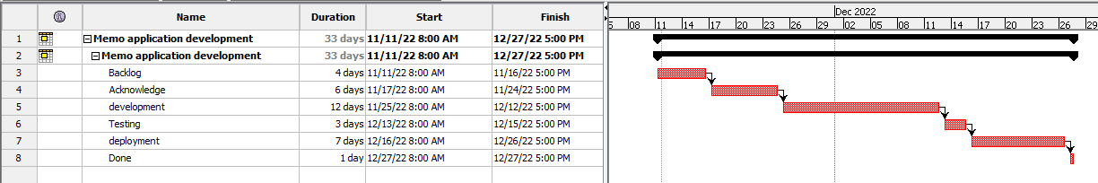

**Figure 5: Evidence of Agile Project Planning, Management, and Development Activities**

(Source: Developed in Project Libre)

In the above figure, the researcher represented the evidence of the kanban agile method of project planning and development.

# Justify the Choice of Professional Tools and Agile Development Method

The justification for choosing professional tools has been described in this segment of the report. Android Studio is the official “Integrated Development Environment (IDE)” for developing Android apps. It is based on “Android studio” as well as has lots of amazing features that help developers code, test, debug, and deploy their “Android applications” (Verma *et al.* 2018). “Android Studio” has provided a rich set of tools for building Android apps, including a debugger, code editor, and device emulator. “Android Studio” makes it easy to create “Android apps” for different types of devices, including tablets, phones, and wearables.

The segment is also going to describe the justification for choosing kanban as the methodology of agile. There is various type of benefits to using the “Kanban methodology” as an “agile approach” to software development. Some of these advantages include:

**Increased Efficiency and Productivity**

Kanban has helped to increase the efficiency as well as productivity of “software development teams” by providing them with a concise and clear workflow. This allows teams to focus on their work and also avoid getting bogged down in unnecessary tasks (Zayat and Senvar, 2020).

**Reduced waste**

Kanban has helped to reduce waste by ensuring that only work that is truly necessary is completed. This has helped to save time as well as resources for the development of the app.

**Improved quality**

Kanban has improved the quality of “software development” by ensuring that teams focus on delivering value to the customer. This has helped to reduce defects as well as improve customer satisfaction.

**Improved Communication and collaboration**

Kanban has improved communication as well as collaboration among members by providing them with a clear and shared understanding of the work that needs to be done. This can help avoid misunderstandings and confusion (Alaidaros *et al.* 2021).

**Increased transparency**

Kanban has increased transparency by providing team members with a clear view of the work that needs to be done. This has helped to improve accountability as well as responsibility.

# Reference List

Alaidaros, H., Omar, M. and Romli, R., 2021. The state of the art of agile kanban method: challenges and opportunities. Independent Journal of Management & Production, 12(8), pp.2535-2550.

Berman, A.L. and Carter, G., 2020. Technological advances and the future of suicide prevention: ethical, legal, and empirical challenges. Suicide and Life‐Threatening Behavior, 50(3), pp.643-651.

Hagos, T., 2019. Android Studio IDE Quick Reference: A Pocket Guide to Android Studio Development. Apress.

Megalingam, R.K., Vishnu, S., Sekhar, S., Sasikumar, V., Sreekumar, S. and Nair, T.R., 2019, April. Design and implementation of an android application for smart shopping. In 2019 International conference on communication and signal processing (ICCSP) (pp. 0470-0474). IEEE.

Müller, R., Klemmt, M., Ehni, H.J., Henking, T., Kuhnmünch, A., Preiser, C., Koch, R. and Ranisch, R., 2022. Ethical, legal, and social aspects of symptom checker applications: a scoping review. Medicine, Health Care and Philosophy, pp.1-19.

Verma, N., Kansal, S. and Malvi, H., 2018. Development of native mobile application using android studio for cabs and some glimpse of cross platform apps. International Journal of Applied Engineering Research, 13(16), pp.12527-12530.

Zayat, W. and Senvar, O., 2020. Framework study for agile software development via scrum and Kanban. International journal of innovation and technology management, 17(04), p.2030002.